CHAPTER 30
INDUCTANCE
Discussion Questions

Q30.1 When the contact is broken the current abruptly decreases and there is a large induced current in the attachment.

Q30.2 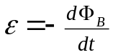 says 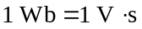. 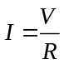 says 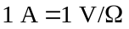.
Therefore, 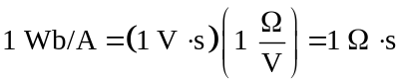, as was to be shown.

Q30.3 Mutual inductance is a measure of how much flux through coil 2 is produced by a given current in coil 1. If coil 2 is rotated 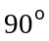 the flux through it is greatly reduced, so the mutual inductance decreases.

Q30.4 The field is confined to the space enclosed by the windings. And if the difference between the inner and outer radii of the toroid is small compared to the inner radius, the variation of the field across the cross section of the windings is small. This makes it easy to calculate the flux through one turn of the coil.

Q30.5 series: If the current passes through each coil in the same sense, then the two in series are equivalent to one coil with twice the length and twice the number of turns. Exercise 30.15 shows that the self-inductance for a long, straight solenoid with 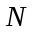 turns, cross-sectional area and length is 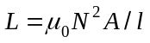. Doubling and causes to increase by a factor of two. The number of turns per unit length is the same as for a single coil so the flux 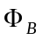 through one turn is the same, but there are twice the number of turns and 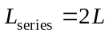.
parallel: The emf across the combination is the emf across each coil. Each coil gets half the current so the magnetic field in each coil is half what it would be with only a single coil in the same circuit. Hence the flux through one coil is halved, the induced emf in each coil is halved, and the inductance of the combination is 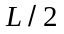; 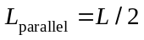.
To get 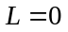 connect the two coils in series such that the current passes around one in the opposite sense than for the other. The induced emfs in the coils are in opposite directions and cancel.

Q30.6 The area is 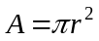. The magnetic field at the center of circular loops of radius is 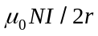. The flux is then proportional to . 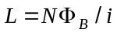 so the coil with twice the radius has twice the self-inductance.

Q30.7 Yes, this would work. The induced emfs for each half of the windings would be in opposite directions and would cancel. There would be no net induced emf and would be zero.

Q30.8 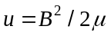 so for the same magnetic field the energy density is larger in a vacuum, since 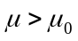. For a long solenoid the field inside the solenoid is given by 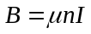. then gives 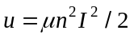. The energy density for constant is proportional to and for the same current more energy is stored when the solenoid is filled with a ferromagnetic material, that has 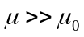.

Q30.9 The voltage across the resistor is proportional to the current through it, the voltage across the inductor depends on the rate of change of the current and the voltage across the capacitor depends on the charge on its plates. (a) In the R-C circuit, just after the switch is closed the charge on the capacitor is zero and the full battery voltage appears across the resistor. In the R-L circuit, just after the switch is closed the current is still zero but is increasing at its maximum rate. The full battery voltage is across the inductor. (b) In the R-C circuit, the full battery voltage is across the capacitor and the current is zero. In the R-L circuit, the current is no longer changing, the full battery voltage is across the resistor and the current is a maximum. The capacitor has no effect initially but causes the current to go to zero as time progresses. The inductor initially limits the rate at which the current can increase but after a long time it has no effect on the circuit.

Q30.10 (a) The voltage across the inductor is proportional to the rate of change of the current flowing in the inductor. The pattern on the oscilloscope is shown in Fig. DQ30.10. (b) Since the voltage across the inductor is determined by the direction of the current, the versus graph is indeed proportional to the derivative of the current graph.

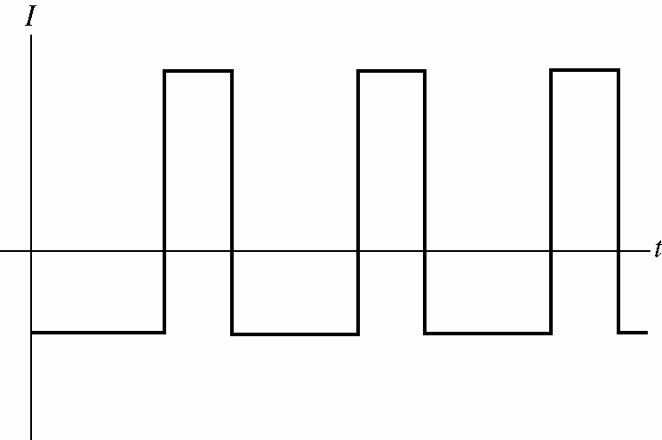
V

t

Figure DQ30.10

Q30.11 The current is now flowing in the negative direction. The current is increasing in magnitude so is becoming more negative, and this means 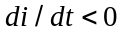.

Q30.12 A decrease in charge on the capacitor corresponds to flowing in the negative direction and 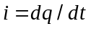 correctly says this.

Q30.13 The potential 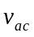 must satisfy Kirchhoff’s loop rule. So when other potentials around the loop change abruptly, such as abruptly adding to the loop, must change abruptly. But 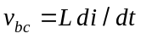. 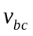 must equal 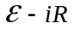 and can’t be larger than . Since is limited, 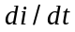 is also limited.

Q30.14 The inductor and resistor are in series; all current through must also pass through .

Q30.15 The voltage induced across the inductor is 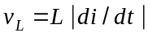. If 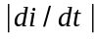 is large then 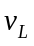 is large. The large emf in the inductor produces a large current in the circuit. 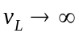 when 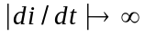 so it is not possible to stop the current instantaneously.

Q30.16 If the circuit is underdamped the current and charge oscillate, but with amplitudes that decrease each cycle of the oscillation. So the energy stored in a cycle would be less than the energy dissipated in that cycle. For an overdamped circuit there are no longer any current oscillations.

